Classifying Sharks using a Dichotomous Key

A classification system is a way of separating a large group of closely related organisms into smaller subgroups. With such a system, identification of an organism is easy. The scientific names of organisms are based on the classification systems of living organisms.

To classify an organism, scientists often use a dichotomous key. A dichotomous key is a listing of specific characteristics, such as structure and behavior, in such a way that an organism can be identified through a process of elimination.

In this investigation, it is expected that you:
- Use a key to identify 14 shark families.
- Study the method used in phrasing statements in a key.

Procedure
- Read sentences 1A and 1B of the key. Then study shark 1 in figure A for the characteristics referred to in 1A and 1B. Follow the directions in these sentences and continue with this process until a family name for Shark 1 is determined.

For example, if the shark has an anal fin, and its body is not kite shaped, following the directions of 1A and go directly to sentence 2. If the shark lacks and anal fin or has a kite shaped body, follow the directions of 1B and go to sentence 10.

- Continue this process with each shark until all animals have been identified. Write the family name on the line below each animal.

- Use figure 1 as a guide to the anatomical features used in the key.

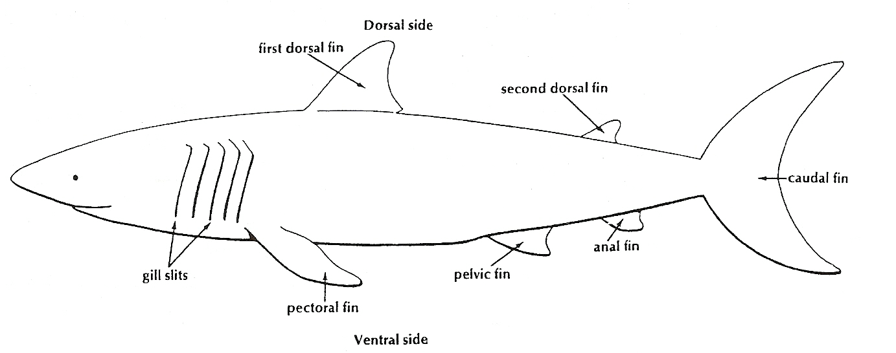
Figure 1 – Anatomy of a Shark

Dichotomous Key to Shark Families

1. A. Body kite-like in shape (if viewed from the top) ..................................Go to statement 12
B. Body not kite-like in shape (if viewed from the top) ............................Go to statement 2

2. A. Pelvic fin absent and nose saw-like ...................................................... Family Pristiophoridae
B. Pelvic fin present .......…........................................................................ Go to statement 3

3. A. Six gill slits present ...........................................................................….. Family Hexanchidae
B. Five gill slits present ......................................................................…….. Go to statement 4

4. A. Only one dorsal fin ..........................................................................…... Family Scyliorhinidae
B. Two dorsal fins ..................................................................................... Go to statement 5

5. A. Mouth at front of snout…………..........……………………………………….…….… Family Rhinocodontidae
B. Mouth on underside of head ............................................................... Go to statement 6

6. A. Head expanded on side with eyes at end of expansion ……………….….. Family Sphymidae
B. Head not expanded .............................................................................. Go to statement 7

7. A. Top half of caudal fin about the same size as bottom half …………….... Family Isuridae
B. Top half of caudal fin different in size than bottom half ……….…………. Go to statement 8

8. A. First dorsal fin very long, almost ½ total length of the body….………… Family Pseudotriakidae
B. First dorsal fin regular length ……………………..................................…….. Go to statement 9

9. A. Caudal fin very long, almost as long as entire body ………………………... Family Alopiidae
B. Caudal fin regular length ................……………………………………………....…. Go to statement 10

10. A. A long needlelike point on end of nose ............................................... Family Scapanorhynchidae
B. Nose without long point ...................................................................... Go to statement 11

11. A. Anal fin absent ....................................……………………………………….…..... Family Squalidae
B. Anal fin present ..........................................……..................................... Family Carcharhinidae

12. A. Small dorsal fin present near tip of tail ................................................ Family Rajidae
B. No dorsal fin present near tip of tail ..................................................… Go to statement 13

13. A. Front of animal with two horn-like appendages .................................. Family Mobulidae
B. No horn-like appendages……….............................................................. Family Dasyatidae
Name: ____________________________________________________ Date: _______________ Block: ______

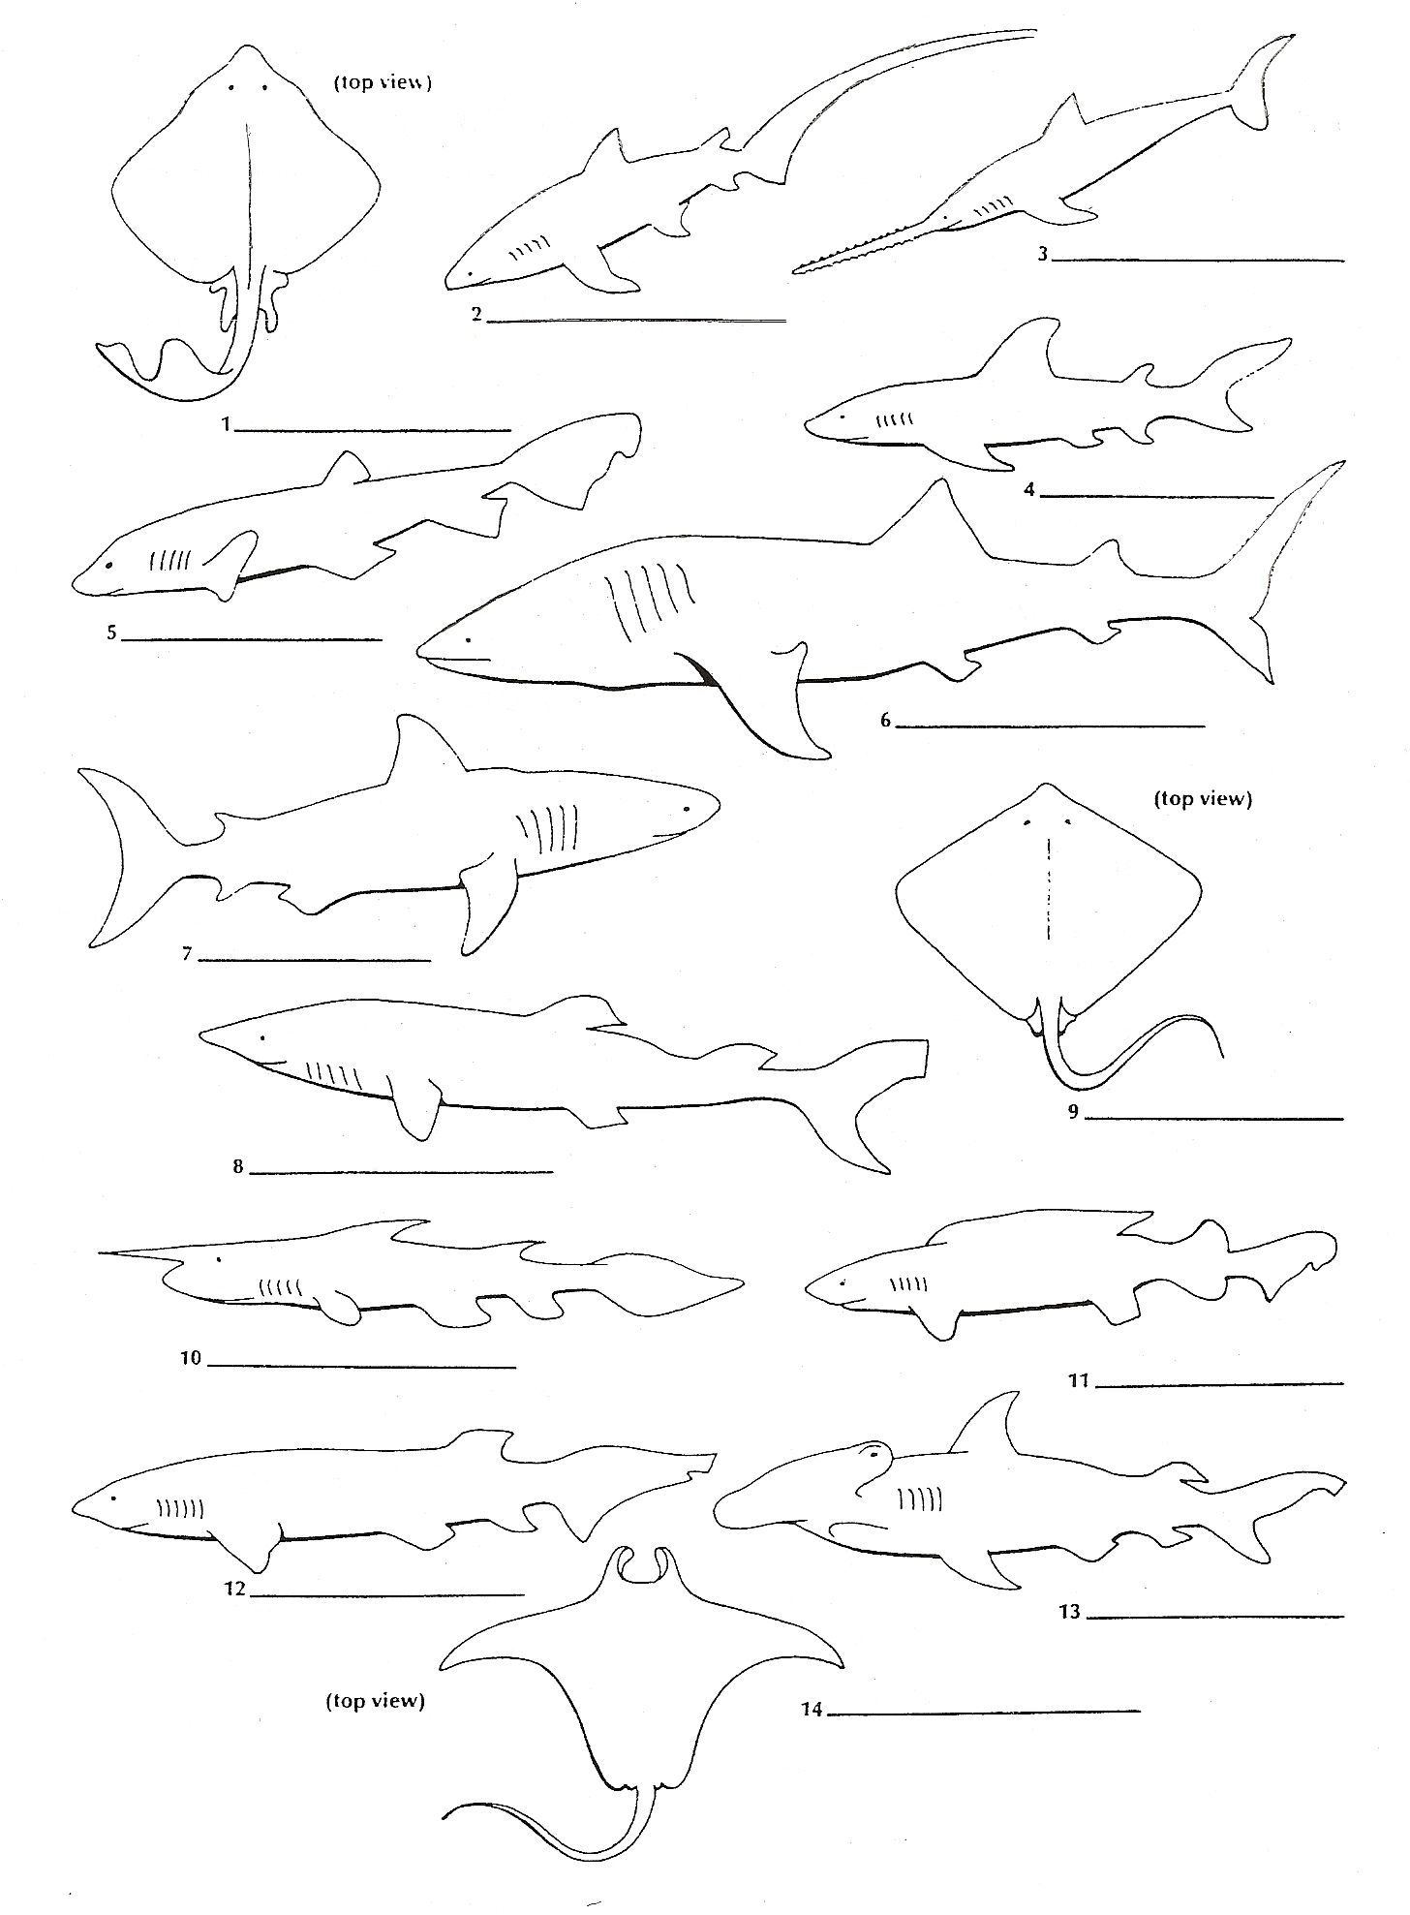
Shark Dichotomous Key Answers

Shark Dichotomous Key Analysis

1. As you worked down the dichotomous classification key to identify sharks, did you go from general to specific characteristics or from specific to general characteristics? Explain your answer using four characteristics that were used in the shark key.

2. Which main characteristics could be used to distinguish shark 4 from shark 8?

3. Which main characteristic could be used to distinguish shark 4 from shark 7?

4. What taxon (classification levels) are represented by the scientific name of an organism? What are the rules for writing the scientific name?
3. Why do biological classification keys always present only two choices at each step?
4. What types of issues would scientists have today if Carolus Linnaeus did not develop the classification system and naming system for organisms?

Shark Answer Key
COMMON NAMES
1. Skate
2. Thresher shark
3. Sawfish
4. Mako shark
5. Cat shark
6. Whale shark
7. Requiem shark
8. Dogfish
9. Sting Ray
10. Goblin shark
11. False Cat shark
12. Cow shark
13. Hammerhead shark
14. Manta Ray

FAMILY NAMES
1.Rajidae
2.Alopidae
3.Pristiophoridae
4.Carcharhinidae
5.Scyliorhinidae
6.Rhinocodonididae
7.Isuridae
8.Squalidae
9.Dasyatidae
10.Scapanohynchidae
11.Pseudotriakidae
12.Hexanchidae
13.Sphyrinidae
14.Mobulidae

